- Can you please move the fund name into the blue banner and remove the text Monthly Performance Scenario:
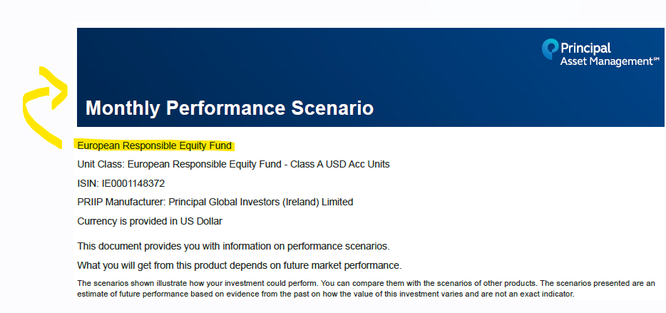

- Can you please put this section in a blue banner :
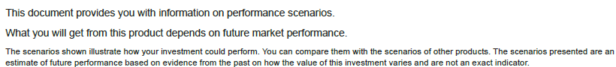

- Can you please reverse the headers as client exemple.
Our template:
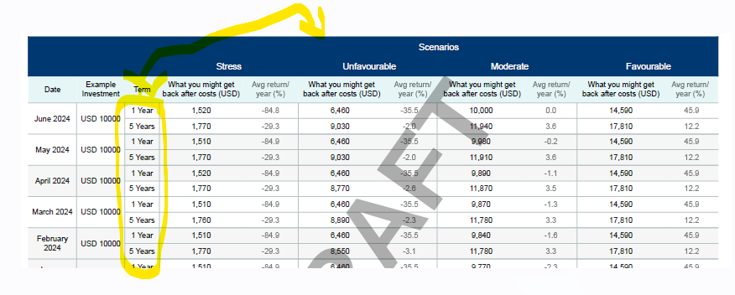

Client template :
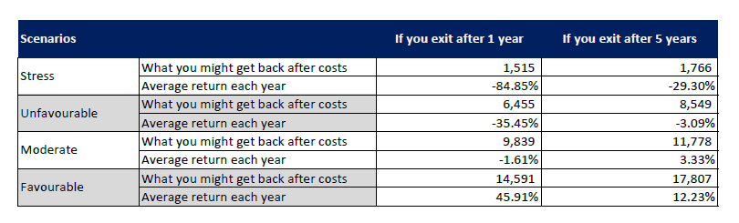
- In the table please remove these 2 columns :
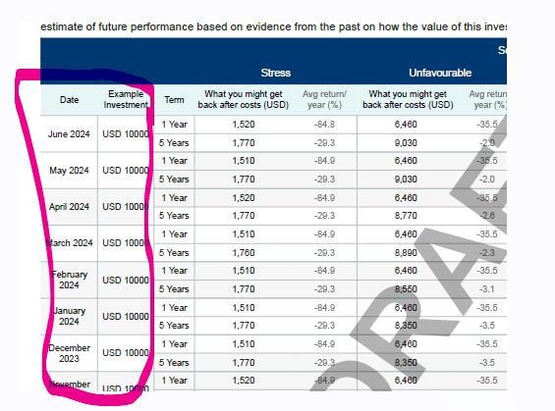

- I added theses 3 WB in the footer but it seems that they don’t appear well:


